|  |
| --- |
| Software Requirements Specification |
| VaccEasy |
| Made By:- Team 3 |

Table of Contents

Table of Contents ii

Revision History ii

1. Introduction 1

1.1 Purpose 1

1.2 Document Conventions 1

1.3 Intended Audience and Reading Suggestions 1

1.4 Product Scope 1

1.5 References 1

2. Overall Description 2

2.1 Product Perspective 2

2.2 Product Functions 2

2.3 User Classes and Characteristics 2

2.4 Operating Environment 2

2.5 Design and Implementation Constraints 2

2.6 User Documentation 2

2.7 Assumptions and Dependencies 3

3. External Interface Requirements 3

3.1 User Interfaces 3

3.2 Hardware Interfaces 3

3.3 Software Interfaces 3

3.4 Communications Interfaces 3

4. System Features 4

4.1 System Feature 1 4

4.2 System Feature 2 (and so on) 4

5. Other Nonfunctional Requirements 4

5.1 Performance Requirements 4

5.2 Safety Requirements 5

5.3 Security Requirements 5

5.4 Software Quality Attributes 5

5.5 Business Rules 5

6. Other Requirements 5

Appendix A: Glossary 5

Appendix B: Analysis Models 5

Appendix C: To Be Determined List 6

Version History

|  |  |  |  |
| --- | --- | --- | --- |
| **Name** | **Date** | **Reason For Changes** | **Version** |
| VaccEasy |  | First time Deployed | v1.0 |
|  |  |  |  |

# Introduction

## Purpose

The purpose of this document is to build a online portal for users in order to keep a track of the vaccine schedule for their children and make easy for look for nearest vaccination centres.

## Document Conventions

* Heading: Times , Font: 18
* Sub-Heading: Times , Font: 14
* Content :Arial, Font: 11

## Intended Audience and Reading Suggestions

This project is a simple prototype for the online vaccination portal with various other features and thus restricted for educational purposes only. This application will be beneficial for parents who have a problem in keeping track of the vaccination schedule for their children.

## Product Scope

The purpose of this project is keeping a track of the child’s vaccination schedule. The parents will have to sign up for the tracking of vaccination schedule with a reminder on the day at which the vaccination is to be applied. Besides, the users will also get the facilities such as vacclocator in which the can locate nearest vaccination centers and camps, BMI calculator, and 27x7 facility for vaccination at home. Users can also get full information about vaccines and its importance from our web application. Users can also consult from various specialists on our website for various issues.

## References

1. Vaccination scenario in India.

<https://www.ncbi.nlm.nih.gov/pubmed/11086301>

1. Common Vaccination problems.

<http://ns.umich.edu/new/releases/23958-most-kids-in-india-lack-timely-vaccinations>

# Overall Description

## Product Perspective

It is a web application which is beneficial for parents with infants. Users will access the website through the URL provided. This website can be accessed in the all the browsers provided that the browser must be of the recent versions. The UI of the website is simple & user-friendly. Various services a provided to users without login.

New Users will have to register for the other facilities. The will be required to give the details such as name, email, mobile no. . These details will be stored in the datastore as entities which will be checked during the login. Registered Users can also use ‘Forgot Password’ facility which they can access in case they forgot the password. Mobile no. of the user will be asked for verification purposes.

## Product Functions

This Website is beneficial for parents with newly born infants and those who are looking for managing their child’s Vaccination schedule.

Users can access services such as schedule service, nearest vaccine center locator, Online chart and approx date calculator on which vaccine should be applied. The users can also download this chart according to their use.

The users who register to the website will be given an additional service of reminder in which the users will automatically get a reminder email on the date on which the vaccine is applied.

## User Classes and Characteristics

The web application should be user-friendly and can be easily used by end users. Any kind of user should feel easy to use the website.

## Operating Environment

This Web application supports all the major browsers and platforms on windows(such as **Internet Explorer 10-11 / Microsoft Edge**, **Mozilla Firefox, Chrome, etc).** Alternative browsers which use the latest version of WebKit, Blink, or Gecko, whether directly or via the platform’s web view API, are not explicitly supported. However, Bootstrap should (in most cases) display and function correctly in these browsers as well.

**Mobile Devices:-**Generally speaking, it supports the latest versions of the each of the major platform’s default browser. Note that proxy browsers (such as Opera Mini, Opera Mobile’s Turbo mode, UC Browser Mini, Amazon Silk) are not supported.

## Design and Implementation Constraints

Developers of the product should be aware that main feature of the intended product is portability. So they should use common libraries and tools that can work with all the common internet browser application with no problem.

Developers should also be careful about the privacy of users. The users data is kept in the datastore with necessary precautions should be taken to protect user data.

The services provided to users should be easy to use and understand for the end users.

# External Interface Requirements

## User Interfaces

The UI of the homepage of the website should be as shown in the below picture:-

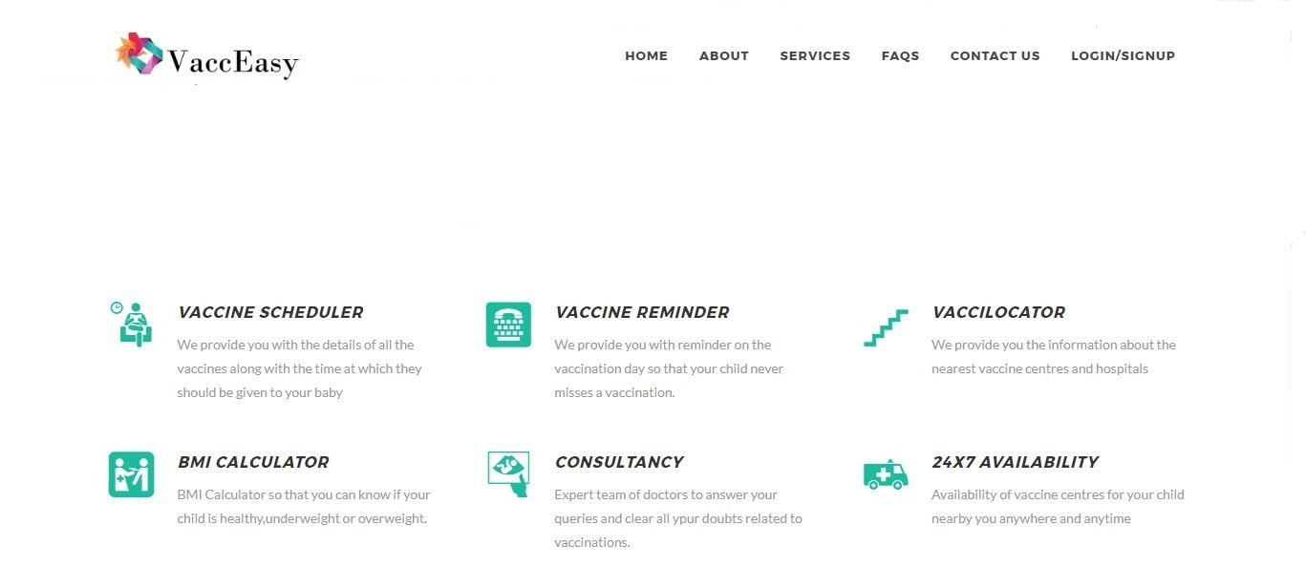

The logo of the product should be as shown in the above image.

The tabs as shown in the image should be linked to the pages with following data.

Following are the pages which should be linked to the tabs shown in figure:-

**About:-** This page contains the information about the need of vaccines, and also tells the people about various important vaccines for infants.

**Services:-** This is a dropdown tab which gives the name of following services.

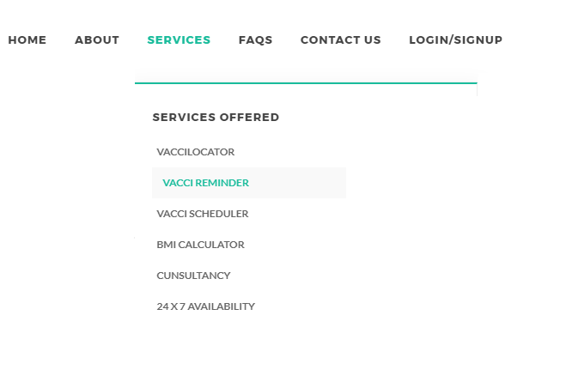

Following are the services which are provided in this web application.

**FAQs:-** This page gives a list of various Frequently Asked Questions on the internet regarding vaccination.

**Contact us:-** This page displays the number on which the users can contact in case of any technical issue. This page will also facilitate a contact via email service in which the user can be abl to snd us email directly to us through that page regarding his query.

**Login:-** This page is used for login of user.

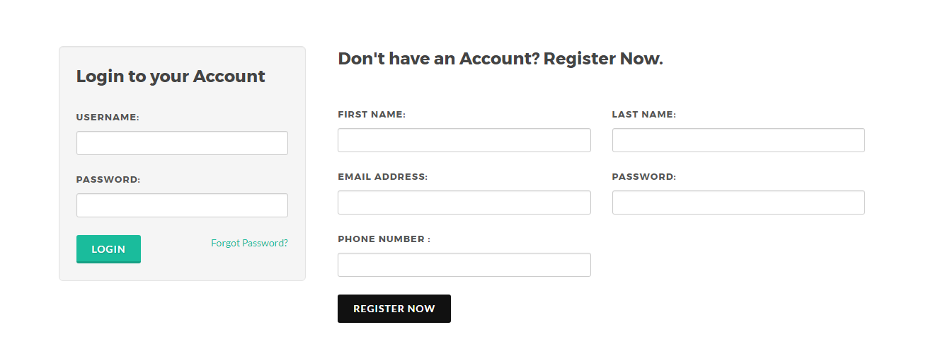

**Register:-** This page will be used for registering the users, It will ask for user’s name ,mobile number ,his email id along with following details of child—

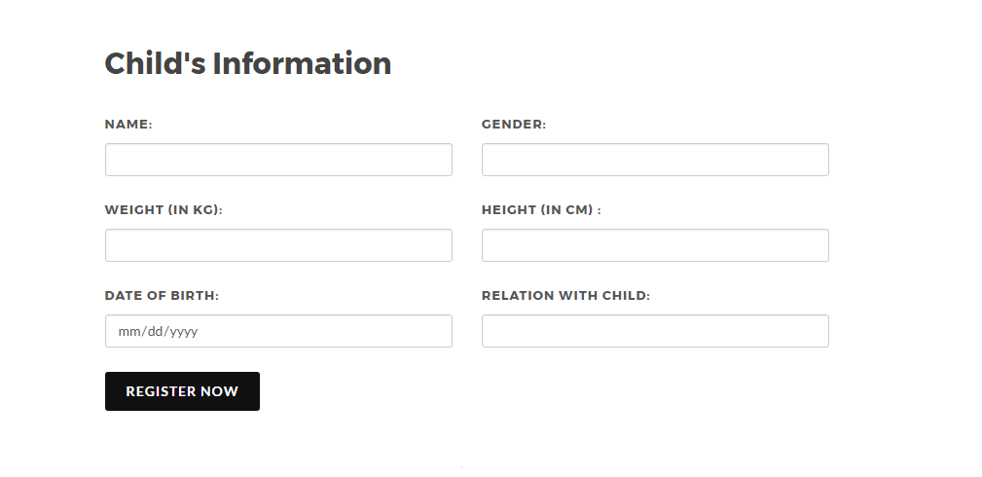

**Dashboard:-** This tab will appear when the user is logged in and will display the details of the child.

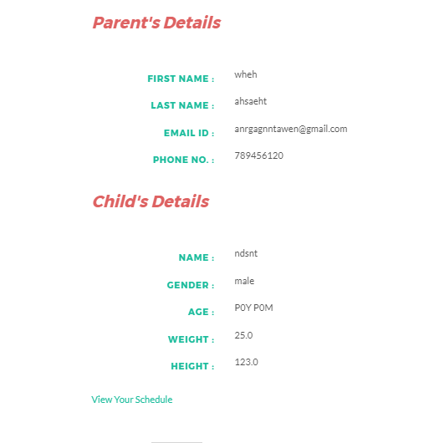

## Hardware Interfaces

This Web application has no dependencies on the configuration of the system provided that the system supports a recent version of the web browser.

## Software Interfaces

The functionalities of web application are to be coded using the java libraries.

Datastore is used for storing the details of the parent, child as well as the login details.

The Designing of the web application is done using html, css, JavaScript and bootstrap. This web application can be viewed in a web browser of recent version.

## Communications Interfaces

It uses HTTPS protocol sending requests and receiving web pages

It uses SMTP protocol for reminder service through email and email query service.

# System Features

Following are the features which are to be involved in this web application:-

## VacciLocator

4.1.1 Description and Priority

It gives the location of the nearest vaccination centers and vaccination camps by taking the person’s location. This feature is of high priority.

4.1.2 Stimulus/Response Sequences

Users can access this feature through the services tab. When we click on the vaccilocator link, a page will open and the site will request for accessing the person’s location. When allowed, a map will be displayed showing the nearest camps and centers.

4.1.3 Functional Requirements

* Requires Google maps api for taking the location of the person and displaying the location.
* User can get the full address for the map

## VacciReminder

4.2.1 Description and Priority

This feature gives the reminder to the user on the child’s vaccination date. The user will get reminder through email. It is a add-on so its priority is low.

4.2.2 Stimulus/Response Sequences

Users will have to login for this facility. This requires the person’s details and the child’s date of birth.

4.2.3 Functional Requirements

* Requires the use of the java mail library.
* Parent’s details and child’s date of birth.
* Sender’s/vendor’s email id.
* Java’s joda-time library for keeping the track of the date on which he vaccination is to be applied.
* Use of SMTP protocol for sending the mail.

## VacciSchedular

4.3.1 Description and Priority

Users can access a static schedule prescribed by our specialists. They can also get a dynamic schedule with the dates on which the vaccine should be applied.

4.3.2 Stimulus/Response Sequences

The site will ask for the date of birth and the child’s name for this facility and the details will be displayed when the values are submitted.

4.3.3 Functional Requirements

* Requires the use of java joda-time library.
* Requires use of tables in html.

## BMI Calculator

4.4.1 Description and Priority

User can calculate the BMI through this feature. Users can access this feature through BMI calculator page which can be opened by services tab.

4.4.2 Stimulus/Response Sequences

Users will have to enter their height and weight in the spaces mentioned. Users will submit their response by clicking “Let’s see” button. In response, the users will get their BMI and a comment depending upon their BMI.

4.4.3 Functional Requirements

* Requires use of html buttons.
* Requires use of JavaScript library for creating functions for response.

# Parent’s details and child’s Other Nonfunctional Requirements

## Performance Requirements

There should be no as such special performance requirements. The web browser should be of the recent version and the version should be stable with minimum bugs. The website will work on small , medium as well as large devices.

## Safety Requirements

An admin page should be added in order to check the images or objectionable content added by the users.

## Security Requirements

It is necessary to add email verification for security purposes. Proper verification of credentials is required during forgot password facility for the privacy of users.

## Software Quality Attributes

The product UI should be user friendly so that it can be easily understood and used by the end users.

# Other Requirements

Use Google datastore for storing the data of the users so that the site can work on the Google app engine after deployment.

Use java EE for back-end programming purposes. However, Other libraries can also be used according to the requirement.

Appendix : Glossary

BMI : Body Mass Index

VacciLocator : (service name) Locating nearest centers

VacciReminder :(service name)Reminder service

VacciSchedular :(service name) Scheduling service

FAQs :Frequently Asked Questions